**PAYMENT GATEWAY**

Online payments go through – payment gateway

* What is payment gateway?
* It is a tunnel that connects bank account to the platform on which purchase is made.
* It is a secure bridge between and bank.
* It is a software that authorizes to make online transaction.
* Different payment methods like net banking, credit debit card, UPI can be used.
* What is UPI?
* UPI ID is linked with user’s mobile number and bank account.
* It enables individuals to transfer money instantly between bank accounts using their smartphones

Order placed 🡪 website takes to PAYMENT GATEWAY 🡪 customer enter details 🡪 payment gateway authorizes transaction by checking the details from bank 🡪 if all is correct bank gives money to payment gateway 🡪payment gateway gives money to merchant

**BILLDESK:**

* A leading payment gateway company in India.
* They use REST API and JOSE Framework for encryption of data.
* JOSE is a framework intended to provide a method to securely transfer claims (such as authorization information) between BillDesk and merchants. The JOSE framework provides a collection of specifications to serve this purpose.
* Billdesk doesn’t provide any public sandbox environment. So it is mandatory to have business details and merchant details to integrate billdesk to your application.
* BillDesk tokenisation solutions make journey for saved card feature simple and scalable.
* Every order created with create order api is valid for 30mins. So user needs to complete transaction within 30mins.
* They provide three different types of services for integration
  + Online payments
  + Recurring payments
  + Platforms and plugins

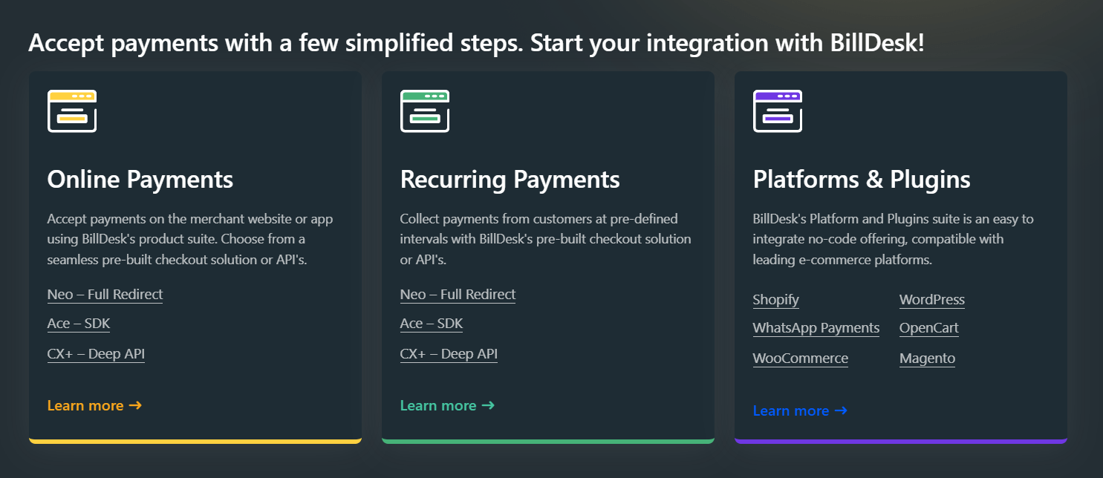

* **Neo – full redirect**:
  + Redirecting user from merchant’s website to BillDesk’s payment gateway.
  + After payment is processed, user is redirected back to merchant’s website with transaction status.
  + It is highly secured and simple to implement.
  + BillDesk ensure securities.
* **ACE – SDK:**
  + Application Client Engine Software Development Kit.
  + Merchants can embed Billdesk’s payment processing directly within their web/ mobile applications.
  + Payment process happens within the app itself.
  + Good user experience as customers stay on merchant’s site/ app.
  + Merchant is partially responsible for managing security of SDK.
* **CX – Deep API:**
  + Customer Experience Deep API.
  + Advanced integration method, gives merchant the full control over the payment flow.

**MANDATE –** Authorization given by customer to business organizations, allowing them to debit customer’s bank account/ card for recurring payments/ transactions.

**ACCEPT PAYMENTS METHODS:**

1. **Neo – full redirect**

In create API merchant details, order details are included

Takes 1 – 3 days

Takes 1 – 3 days

YES

NO

Original amount is transferred to merchant’s account (EX: 490)

Convenience fees is transferred to Billdesk’s account (EX:10)

Transaction failure response to redirect URL given in ‘ru’

Transaction success response and redirected to URL given in ‘ru’

Money is deposited in escrow account (EX: 500)

Redirected to BillDesk Payment page

Billdesk payment page gets details of customers. Asks for a payment method credit/ debit/ UPI/ wallet. Initiates transaction by checking with customer’s bank account

User clicking PAY/ CHECKOUT button

Create order API is requested

Payment success

* Merchant is requested to contact billdesk and provide necessary info, bank details, documentation regarding the business.
* Billdesk provides merchantID, clientID and more info to integrate Billdesk payment gateway to your business platform.
* Neo full redirect also has a feature of SPLIT PAYMENT. The amount can be deposited to 1/ more merchant’s account. For this merchant should provide necessary details at initial stage. So billdesk provides child merchant ids too.
* After all process, by clicking pay button, CREATE API is called. It has details of order and merchant, redirect url after payment is completed.
* To trigger it a form with *action: ‘url of billdesk’* must be given.
* User can use any of the payment gateway method like credit/ debit/ UPI/ wallet to complete the transaction.
* After payment is completed successfully, transaction status with order detail is sent as response to the Redirect URL.
* By deducting convenience fee from the amount, remaining amount is credited to merchant’s account. The convenience fee is credited to Billdesk’s bank account.
* If needed AVS (Account Validation Service) is added as an object in CREATE ORDER API.

REFUND PROCESS:

* When customer needs refund, the initiate it by clicking REFUND button.
* So, when refund is triggered, CREATE REFUND API is called.
* It has details like orderID, transactionID, merchantID.
* Billdesk automatically initiates refund process. Billdesk submits refund request to merchant.
* If merchant approves it, then refund request is satisfied by deducting amount from merchant’s account and crediting it into customer’s account.
* In some case like order cancellation, according to billdesk’s terms and condition billdesk automatically deducts amount from merchant’s account.
* Status of refund can be retrieved by using RETRIEVING REFUND API. This is triggered when user clicks on check refund status.

1. **Ace – SDK**

User clicking PAY/ CHECKOUT button

Create order API is requested

Incorporate JS & CSS links

2 objects launched for ACE - SDK

flow_config

(defines how aspects of SDK will render)

config

Include the function to launch

Include onload close event on return URL

Check transaction status

Refund if needed

Check refund status

* Embedded payment within the app/ website.
* Shows modal window (pop up like) inside the application.
* Initially, CREATE ORDER API is created.
* If needed AVS (Account Validation Service) is added as an object in CREATE ORDER API.
* JS, CSS links for modal window is added as script files.
* Objects – *flow_config, config* is added.
  + Flow_config:
    - defines how certain aspects of SDK will render.
    - Customizations for website needed by merchant can be included here.
* Config:
  + Must contain merchantLogo, flowType
* Pass *config* to Billdesk function as **window.loadBillDeskSdk(config)**
* Include onload close function on return url as **<html><head><title>BillDesk</title></head><body onload="window.close();"></body></html>**
* Final code looks like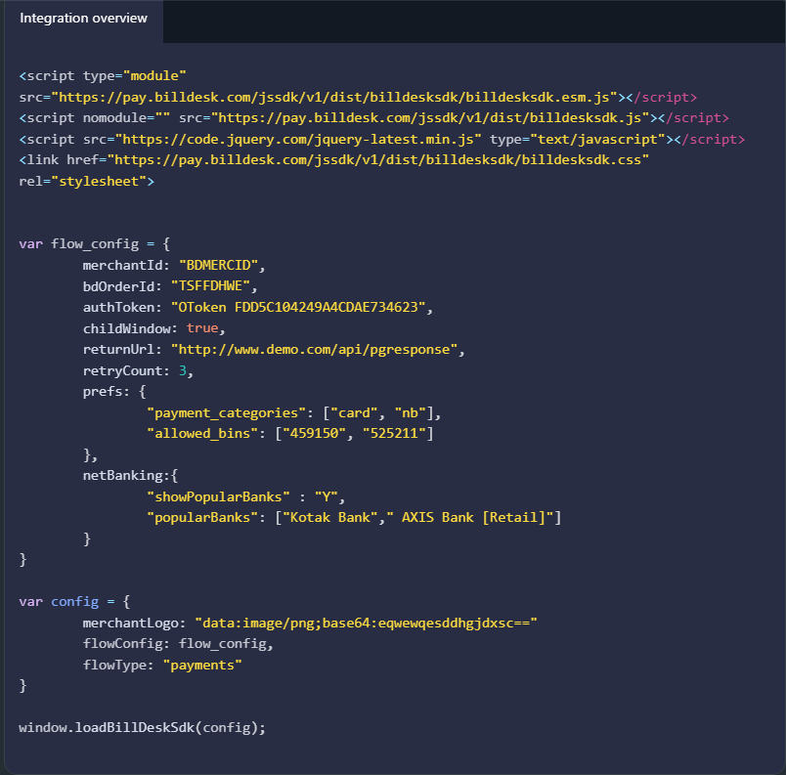

1. **Flutter SDK:**

* Allows billdesk payment with flutter application.
* Download flutter libraries
* Create flutter app and copy SDK libraries and pubspec.yaml files in the flutter project.
* Add configurations for pubspec file.
* Navigate to flutter app and run **$ flutter pub** get to fetch and install the dependencies.
* Create order step using CREATE ORDER API.
* Build **sdkConfig –** it acts as a wrapper required for initialising and configuring the BillDesk Flutter SDK. It is the main configuration object for SDK integration.
* Build **sdkConfigJson** **–** JSON object that represents the configurations that merchant will prepare to their integration.
* Build **flowConfig**.
* Include **SDKWebView.openSDKWebView(sdkConfig)** to launch BillDesk Flutter SDK. This step is used to pass scripts and configuration created in previous steps.
* Capturing the transaction response
  + Initialize responseHandler. ResponseHandler – handles response and errors generated by SDK during transaction process.
  + Merchant needs to implement two functions within the **ResponseHandler class: 1. onTransactionResponse** 2. **onError**. These functions will be called by the SDK to provide the results of a transaction or report any errors encountered during the process.
  + The TxnInfo class represents transaction information and is used to encapsulate the details of a transaction response.
* Finally, transaction status can be checked, refunds can be made, refund status can be checked.

1. **CX + - Deep API**

* Allows customers to be on merchant’s website/ app for making the payment.
* Complete customization is available.
* Depending on payment method, work of API is separated.
* **For Card (PAN Based Transaction)**
  + Create transaction API
  + Use 3DS for security purposes.
    - 3DS (Three Domain Secure) – OTP, Biometric
* Once user completes authentication (like entering OTP), need to confirm payment using update transaction UPI.
* It can also be done by saving the details of the card.
* To update transaction, use UPDATE TRANSACTION API.
* Same goes for card, UPI, wallets transaction.

1. **Payment Links:**

* The BillDesk payment links suite offers merchants an easy option to collect payments from customers.
* No website/ app is needed for this.
* Create payment link 🡪 retrieve payment link 🡪resend payment link 🡪delete payment link.
* **CREATE PAYMENT LINK:**
  + Creates payment link with create link api.
  + It can be sent to merchant via E-mail, SMS.
  + Can be done as FULL PAYMENT, PARTIAL PAYMENT, AVS OBJECT.
  + Each has separate code with some modifications.
* **RETRIEVE LINK:**
  + This API can be used to fetch the status of an existing payment link.
  + It can be done by using mercid/ merc_link_ref_no.
  + This is obtained as a response for create link api.
* **RESEND LINK:**
  + This API can be used to resend notifications to customer for their previously created link.
* **DELETE LINK:**
  + This API can be used to delete a previously created payment link.

**MANAGE PAYMENTS METHODS:**

* Retrieve transaction
  + The Retrieve Transaction API can be used to understand various details of the transaction including payment status, refund status etc.
    - RETRIEVE TRANSACTION API is used

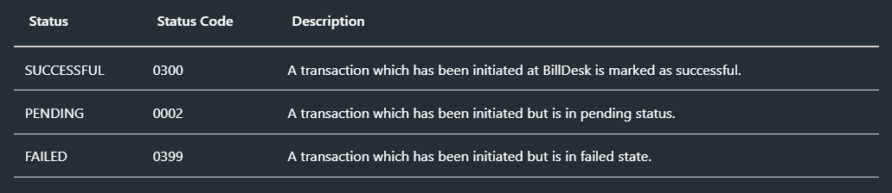

* Refunds
  + When the merchant wants to return the funds to their customer, for example, if the customer returned an item, merchant can initiate a refund. Merchant can either do a full refund or a partial refund.
    - CREATE REFUND API, RETRIEVE REFUND API is used

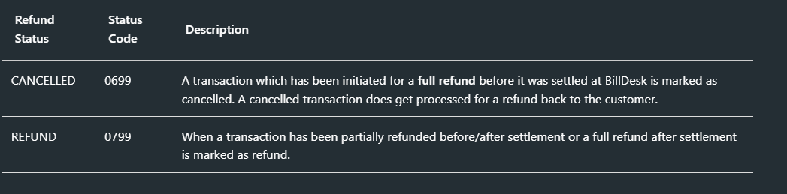

* Settlements
  + The BillDesk Settlement API allows merchant to query for the settlement and its related details. BillDesk shares the settlement report with the merchant that has details about the transactions (successful, refunded and chargebacks).
  + RETRIEVE SETTLEMENT API is used.
  + Merchant can retrieve the settlement report by simply providing merchant id & date range. Another option is to retrieve settlement report by sending the payment voucher number (if from_date is not available) along with merchant id.

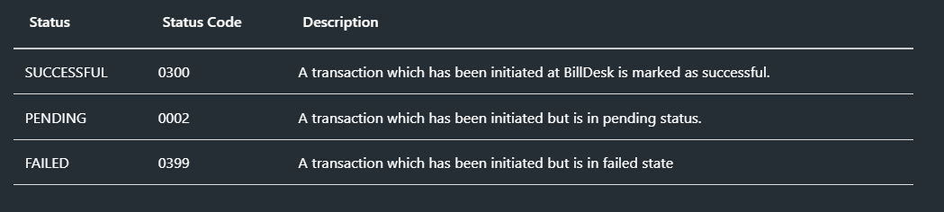

**PLATFORMS AND PLUGINS:**

* For integrating billdesk with shopping platforms, billdesk offers plugins which can be installed and used directly.
* As a prerequisite, merchant must be onboarded by giving necessary details to billdesk team. So that merchant will be provided with merchantid and some more information which will be needed for integration.
* Available platforms for billdesk integration with detailed steps in billdesk documentation are **shopify, whatsapp payments, woocommerce, PMPro, EDD, WordPress, OpenCart, Magento, VirtueMart, PrestShop, Drupal Commerce, nopCommerce, osCommerce, Zen Cart**.

**FOREIGN CURRENCIES AND TAXES:**

* BillDesk offers payment in INR (Indian currency)
* Billdesk doesn’t provide international money conversions. So merchant must do currency conversion externally and pass the INR amount to the billdesk payment gateway.
* Currency conversion is done with API. Here exchange rate API is used.

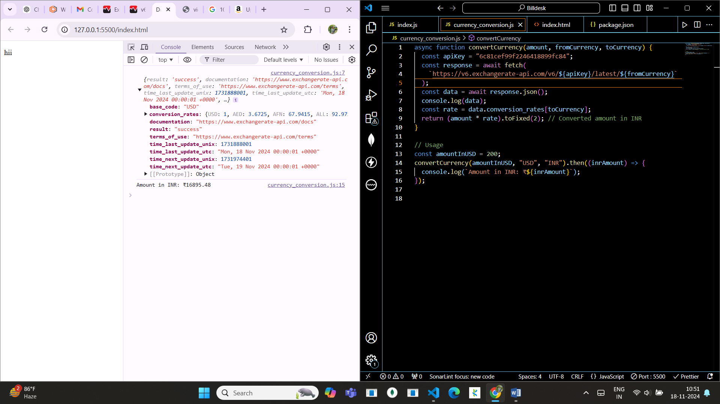

* Many cases are available for shopping a product in Indian e-commerce website will billdesk payment integration
  + Indian user purchases a product in INR and deliver to Foreign countries.
  + Indian user purchases a product in other currency and deliver to Foreign countries.
  + Foreign user purchases a product in INR and deliver it to India.
  + Foreign user purchases a product in other currency and deliver it to Foreign
* **Indian user purchases a product in INR and deliver to Foreign countries.**
  + **Sample scenario:** A person in Chennai purchases a product by paying in INR and delivering it to foreign.
  + Delivery address will be foreign address.
  + So the person who receives the product is in-charge for paying the custom-duties tax, cross-border tax.
  + Customer should pay Custom taxes imposed by the country.
* **Indian user purchases a product in other currency and deliver to Foreign countries.**
  + **Sample scenario:** Here the Indian user must pay currency conversion tax (mostly 1% - 3.5%) and custom taxes imposed by delivery country.
* **Foreign user purchases a product in INR and deliver it to India.**
  + Here the foreign user must pay currency conversion (USD to INR) tax (mostly 1% - 3.5%).
  + India doesn’t have any GST for importing and exporting products. So there is not need to pay amount for delivery
* **Foreign user purchases a product in other currency and deliver it to Foreign**
  + For currency conversion amount should be paid by customer and customs duties/ sales tax/ VAT must be paid by customer.
* For finding currency conversion rate Exchange rate API can be used.
* For finding tax imposed by importing countries for the product TaxJar/ TaxRate.io API can be used.

Checkout

Amount to be paid

Maybe deduction of convenience fee by Billdesk

Other than INR

INR

TAX by foreign countries

Billdesk redirection

Currency conversion API

Amount credited to merchant account

Remaining amount credited to billdesk account.

Conversion fee retained by currency converted bank

Total amount to be paid

GST tax